- Delivery Time Slot issue => Even if time is available for next day, it shows unavailable.

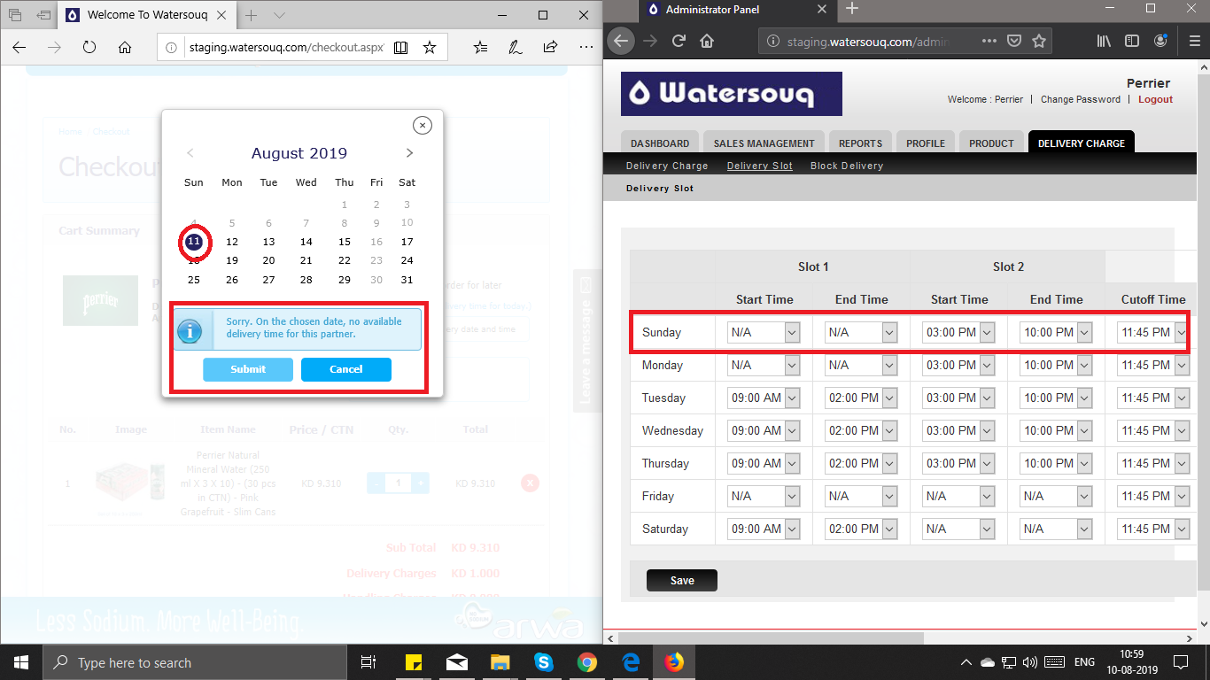

- Delivery Time Slot issue => Even when only 1 slot is available for a specific date, it doesn't appeares to be selected by default.

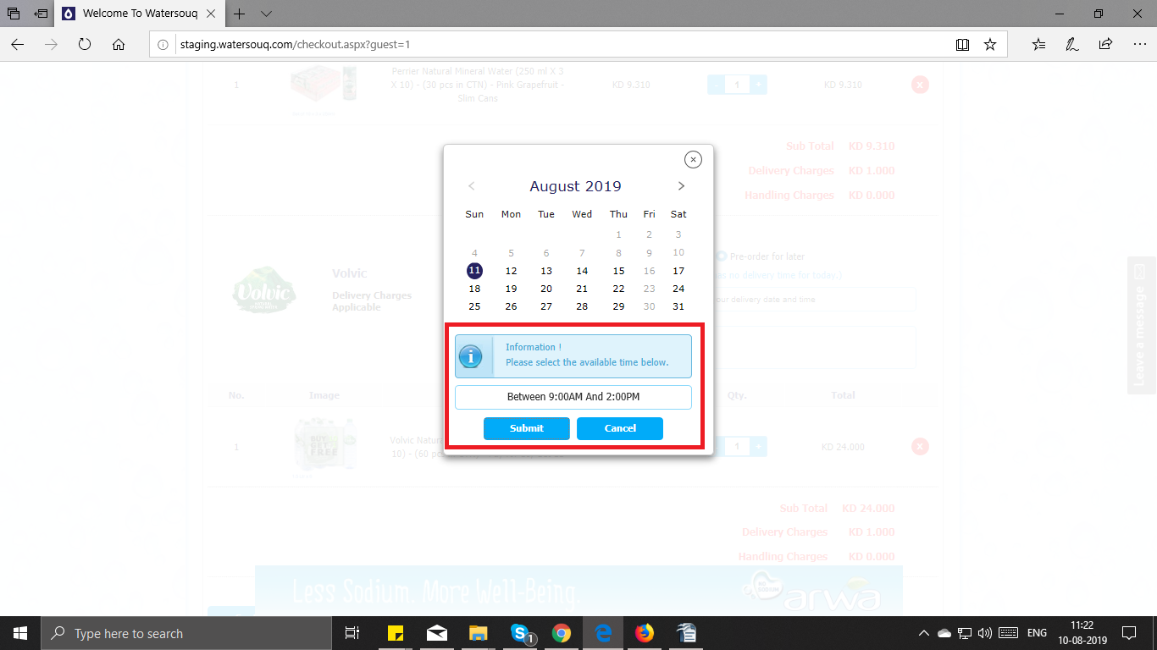

- Same Day Delivery => When only 1 slot is available, it is not showing selected by default.

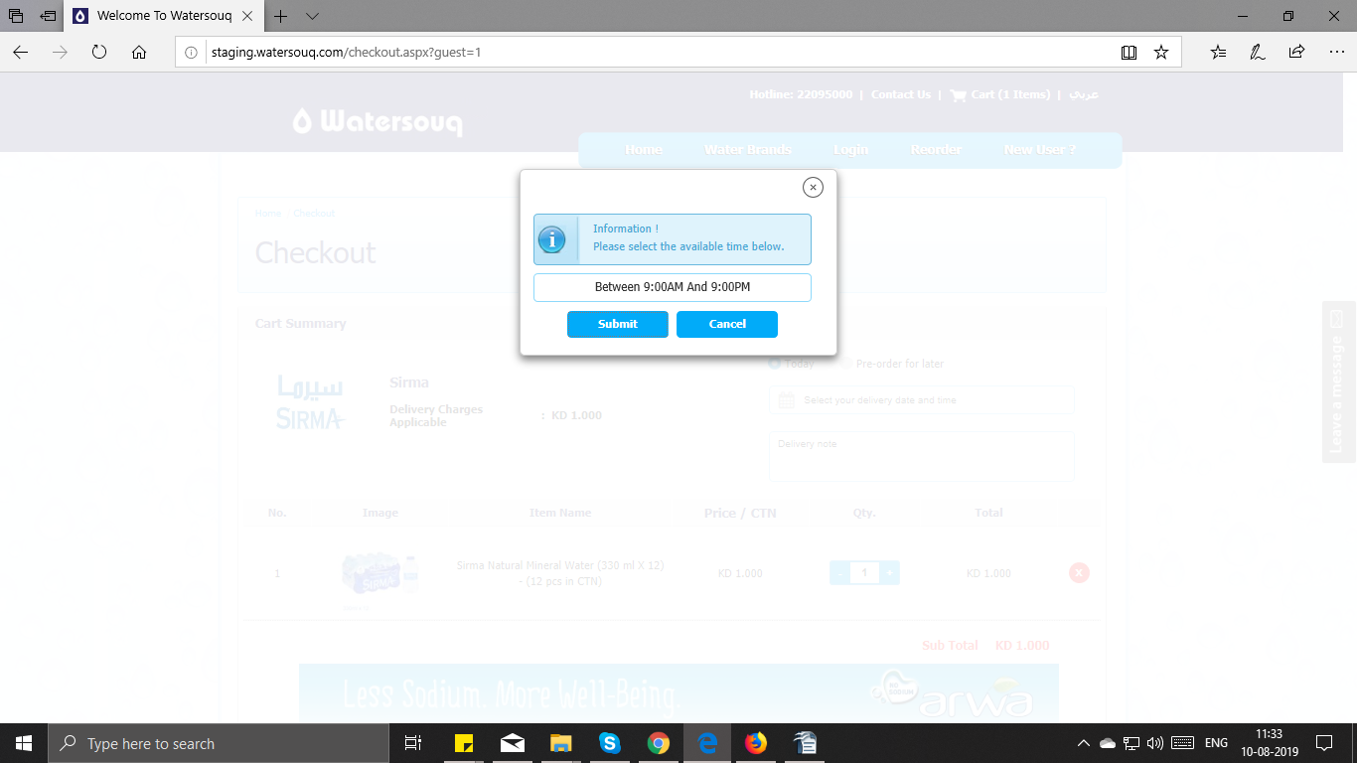

- Same Day Delivery => When clicked on CONFIRM ORDER, unknown address error shown. "Please Save or Cancel editing your address to proceed)"

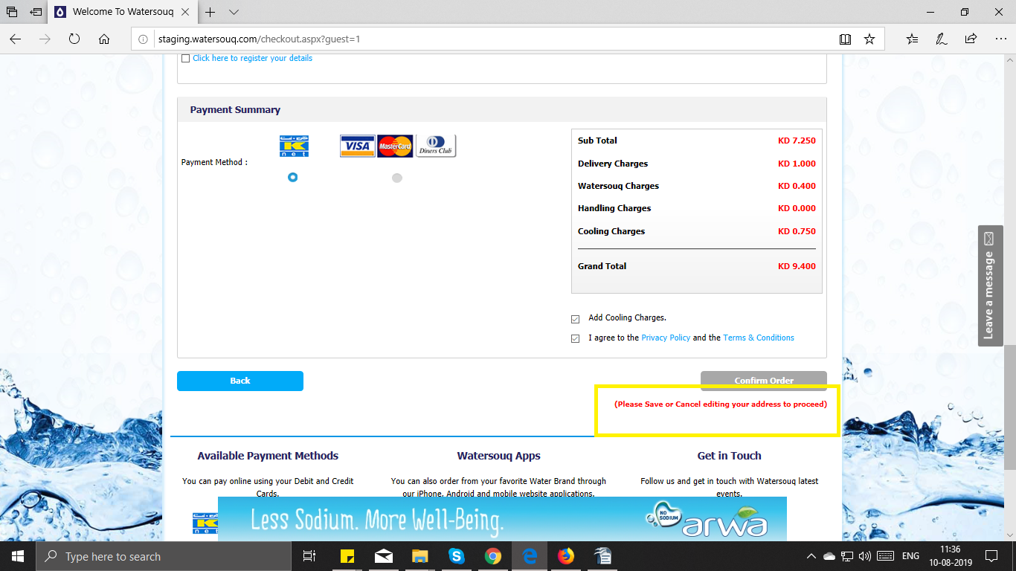

- Same Day Delivery=> When Cutoff time was set at 12PM for a brand, Even after 12pm same day delivery order was accepted.

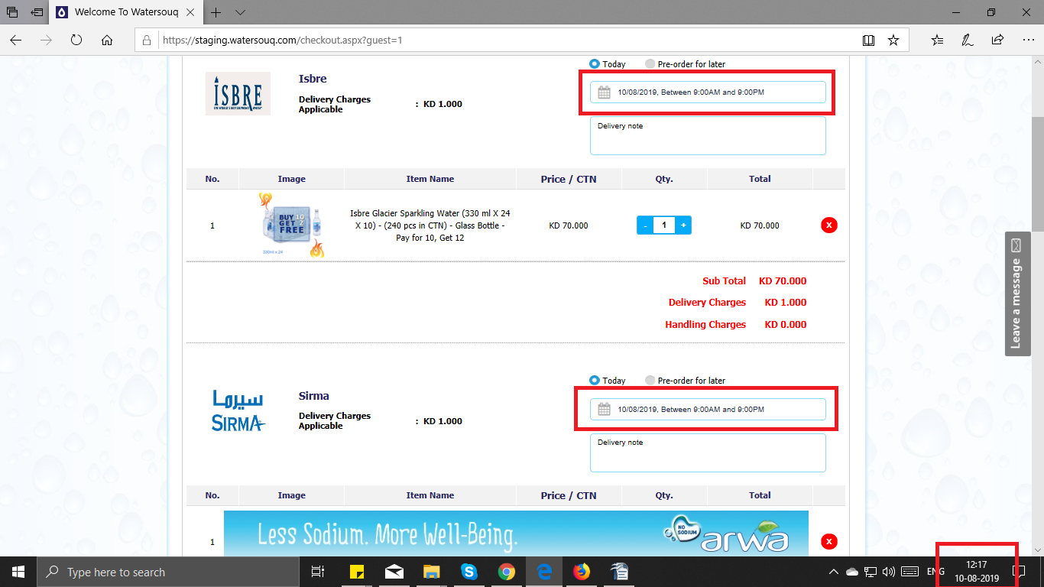
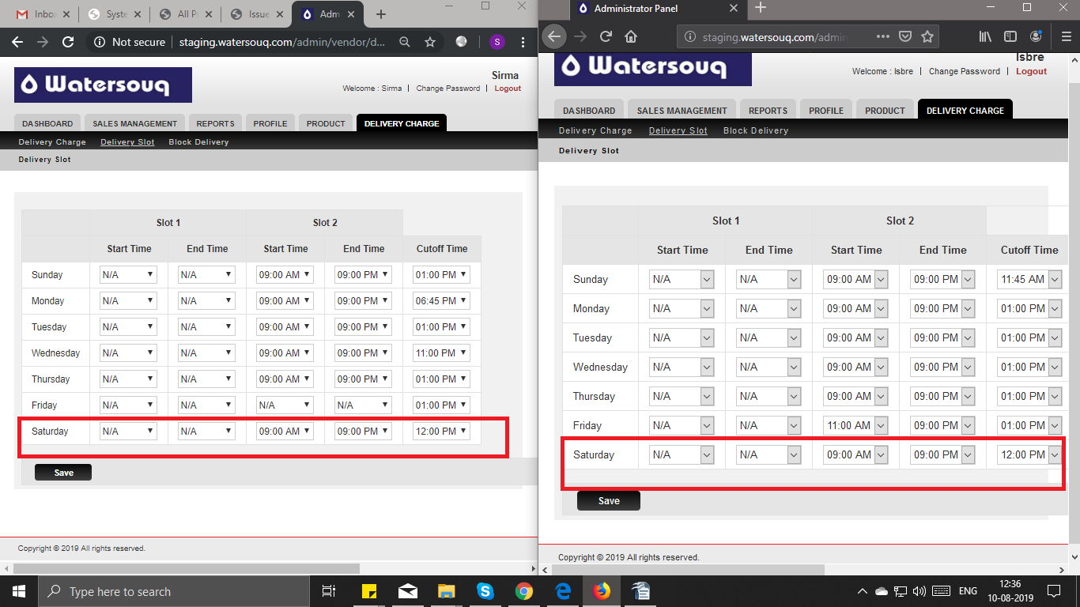
- Allowing same day delivery for the Brand which is not in option for "same day delivery".
- For some brands, after cut off time, next date will not be available for delivery. it should go to next available date. (not working).
- Next Day Delivery - On load, system should automatically select the next available delivery date/time for that particular brand. (not working).

